Untuk Pengguna Indicator Haji Sam,Suggestion TimeFrame adalah M5/M15.
Valid untuk semua pair.Fahamkan dulu SOP dan rajin buat backtest.Setelah faham baru entry di real akaun.

ADA 3 JENIS INDICATOR UTK SETTING
1. ENVELOPES
2. RELATIVE STRENGTH INDEX (RSI)
3. MOVING AVERAGE (MA)

Indicator Setup
Step 1: Main Chart (Ada 4 setting ENVELOPES)
Envelopes – Period 50, Deviation 0.823, Shift 0, Method Smoothed, Apply to Close, Upper Band green, Lower Band red
Envelopes – Period 50, Deviation 0.783, Shift 0, Method Smoothed, Apply to Close, Upper Band green, Lower Band red
Envelopes – Period 50, Deviation 0.763, Shift 0, Method Smoothed, Apply to Close, Upper Band green, Lower Band red
Envelopes – Period 50, Deviation 0.423, Shift 0, Method Smoothed, Apply to Close, Upper Band green, Lower Band red

Step 2: Indicator Window (Ada 1 setting RSI & 10 setting MOVING AVERAGE)
Relative Strength Index – Period 1, Apply to Close,Level “20” Description BUY + Level “80” Description SELL
Moving Average – Period 1, Shift 0, Method Smoothed, Apply to Close, Color orange
Moving Average – Period 2, Shift 0, Method Smoothed, Apply to Close, Color orange
Moving Average – Period 3, Shift 0, Method Smoothed, Apply to Close, Color orange
Moving Average – Period 4, Shift 0, Method Smoothed, Apply to Close, Color orange
Moving Average – Period 5, Shift 0, Method Smoothed, Apply to Close, Color purple
Moving Average – Period 6, Shift 0, Method Smoothed, Apply to Close, Color purple
Moving Average – Period 7, Shift 0, Method Smoothed, Apply to Close, Color purple
Moving Average – Period 8, Shift 0, Method Smoothed, Apply to Close, Color purple
Moving Average – Period 9, Shift 0, Method Smoothed, Apply to Close, Color purple
Moving Average – Period 10, Shift 0, Method Smoothed, Apply to Close, Color purple
Step 3: Tengok list indicators bawah – Pastikan sama denga saya punya dulu
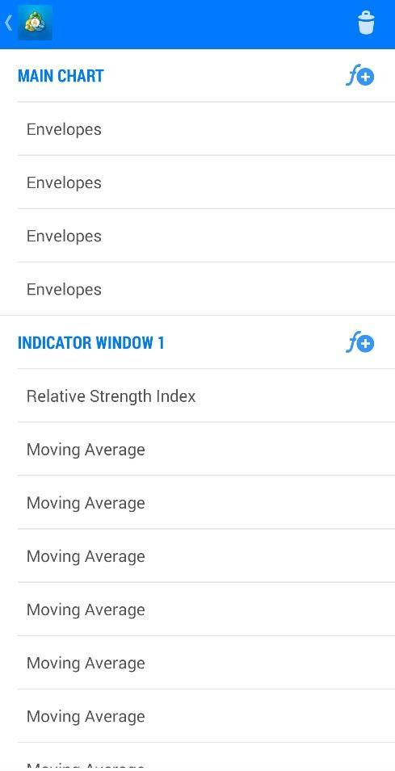
Lepas setup - Follow 2 SOP je boss
STEP 1:
TUNGGGU Candle sentuh line Envelops atas: Sell
TUNGGU Candle sentuh line Envelops bawah: Buy
STEP 2:
RSI level bawah 20: Buy
RSI level atas 80: Sell
Entry bila dalam zone sell/buy envelope
Confirmation Di RSI : Tunggu MA bersilang ke atas(buy) / ke bawah(sell)
Biasanya untuk sell: MA purple di atas/ untuk buy: MA purple di bawah
JIKA CUKUP 2 STEP DI ATAS BARU ENTRY.JIKA TIDAK CUKUP DILARANG ENTRY.
Untuk letak SL sila letak di support/resistance yang terdekat.
Ada 2 cara untuk close/take profit.
1.Close apabila Moving Average sentuh pada level RSI 20/80.(Recomended)
2.Close apabila Moving average mula bersilang/berlawan dengan entry kita.
Boss backtest dan demo dulu tgk pair apa yg valid.
